Nalongsone Danddank Student ID : 14958950 StarID: jf3893pd

Email: [nalongsone.danddank@my.metrostate.edu](mailto:nalongsone.danddank@my.metrostate.edu)\

**ICS 432 - 01 — Distributed and Cloud Computing Fall 2021**

**Assignment #4 :** Using APIs to access a Firestore Collection

Homework screenshot #1:

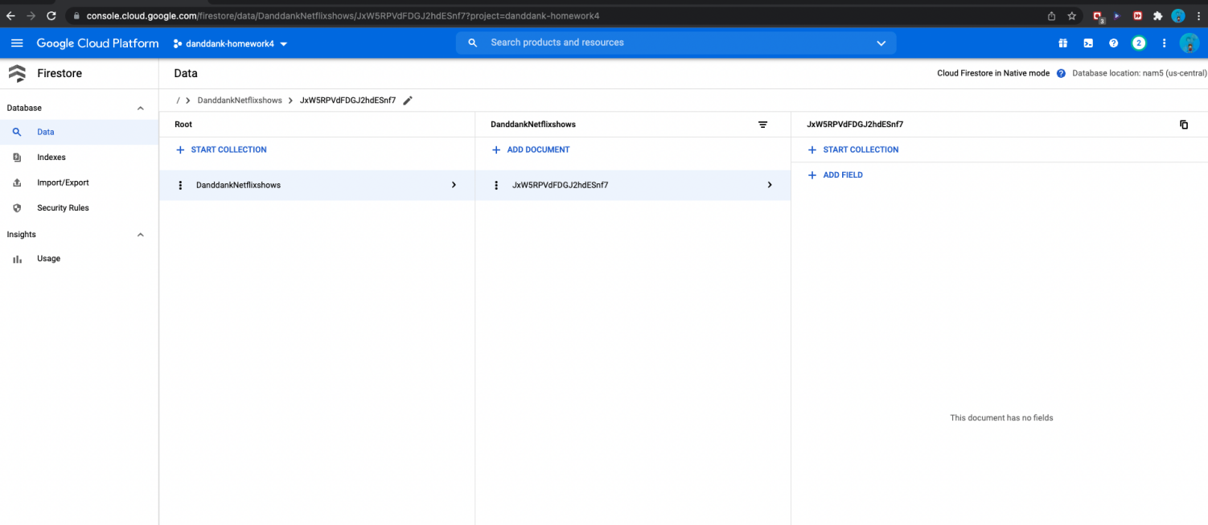

Homework screenshot #2:

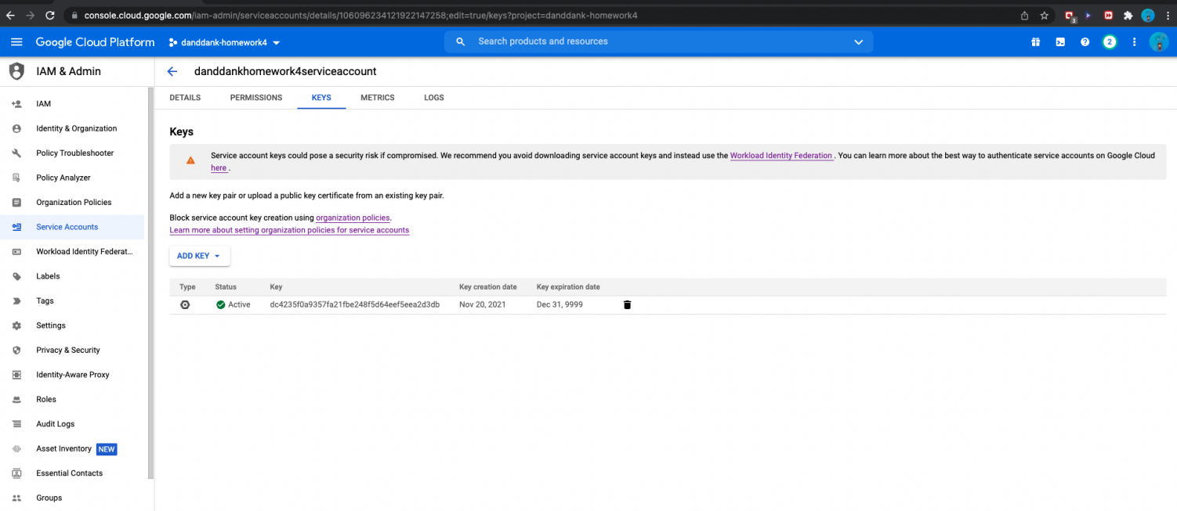

Homework screenshot #3:

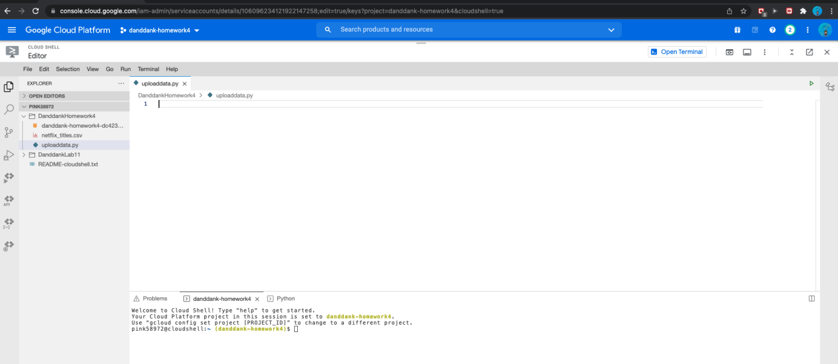

Homework screenshot #4:

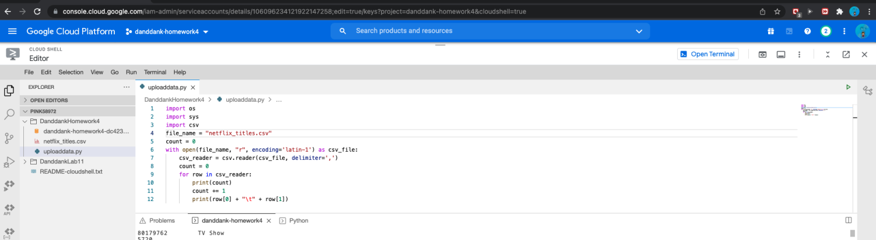

Homework screenshot #5:

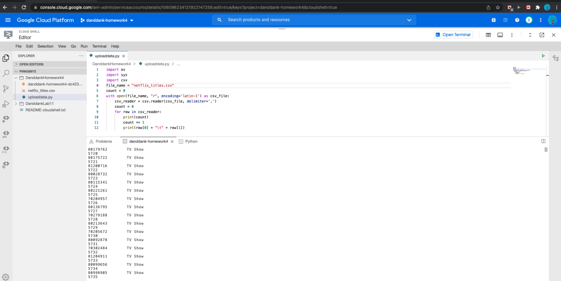

Homework screenshot #6:

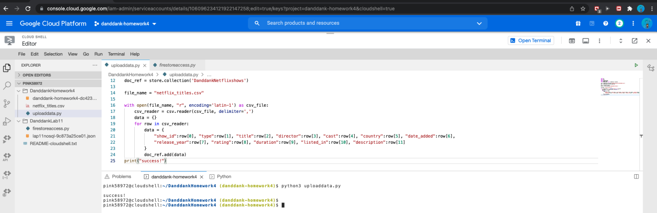

Homework screenshot #7:

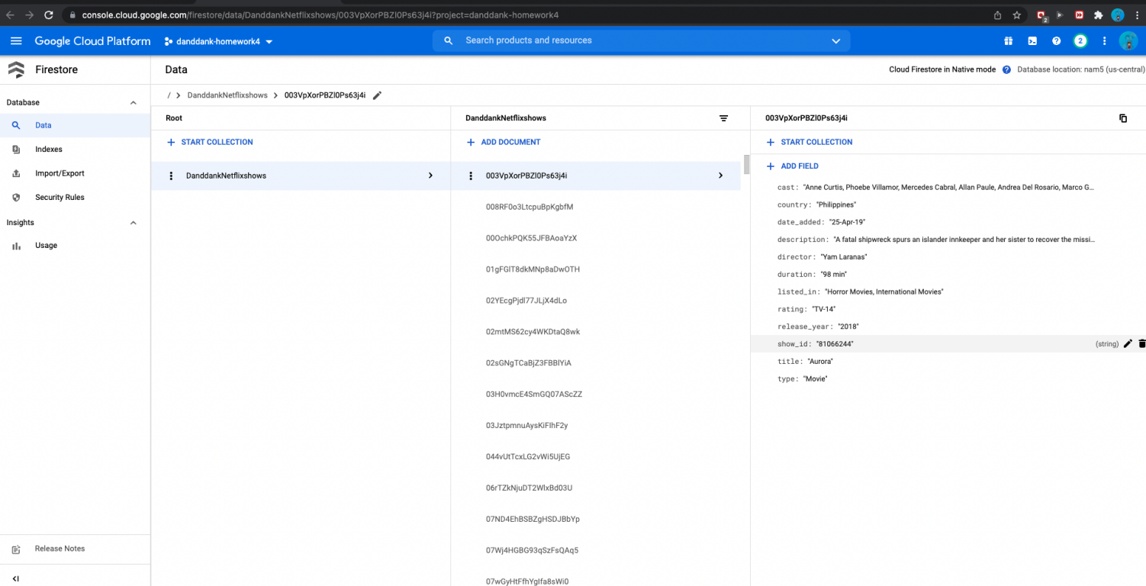

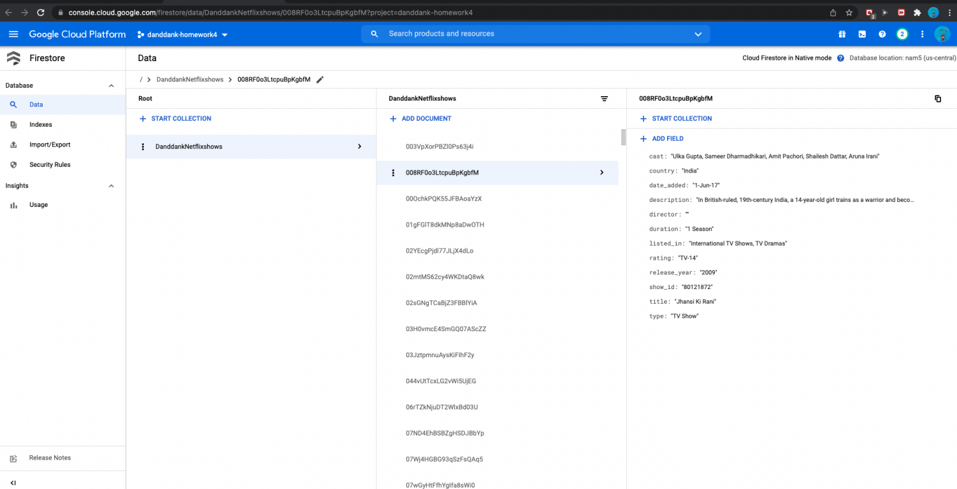

Homework screenshot #8:



Homework screenshot #9:

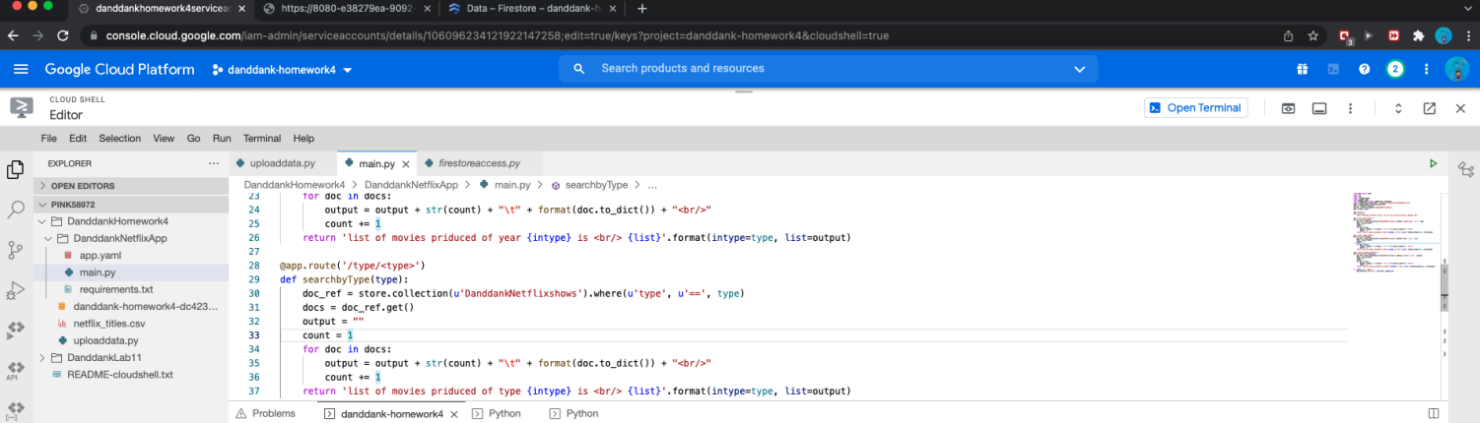

Homework screenshot #10:

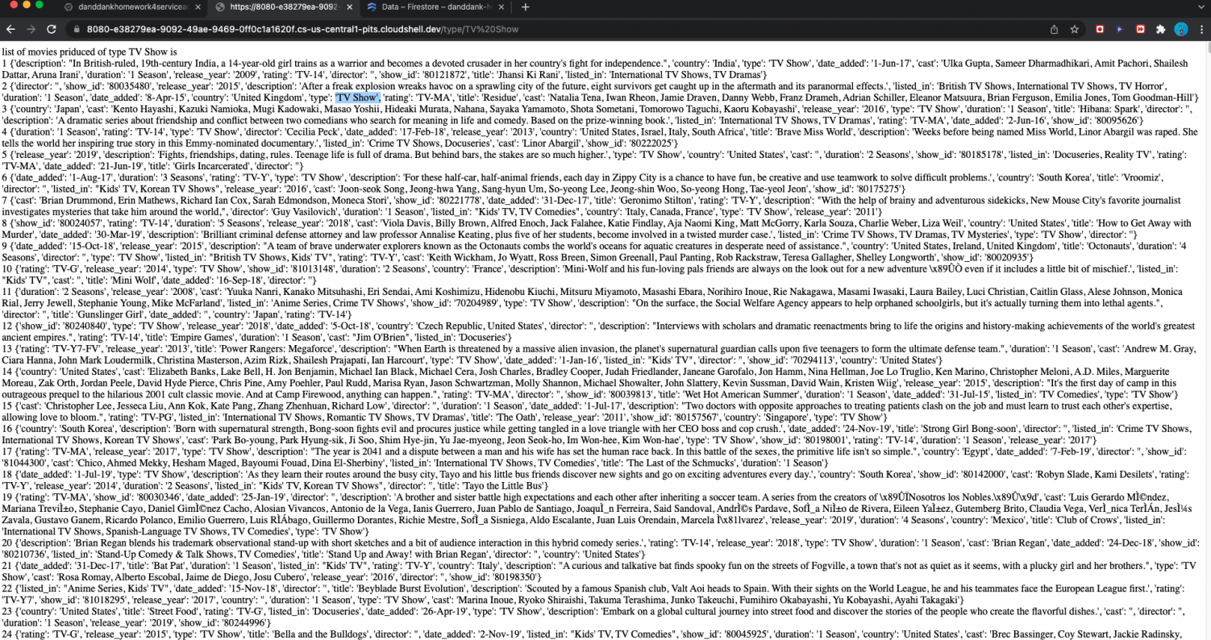

Homework screenshot #11:

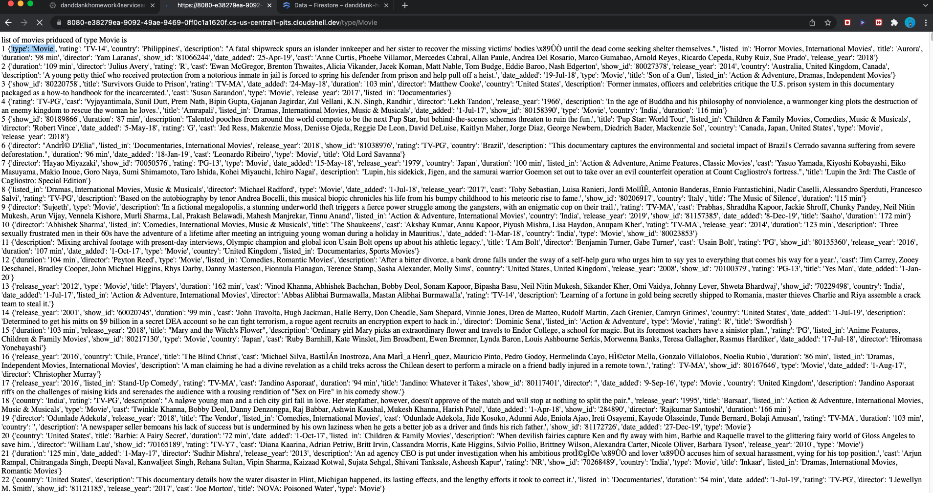

Homework screenshot #12:

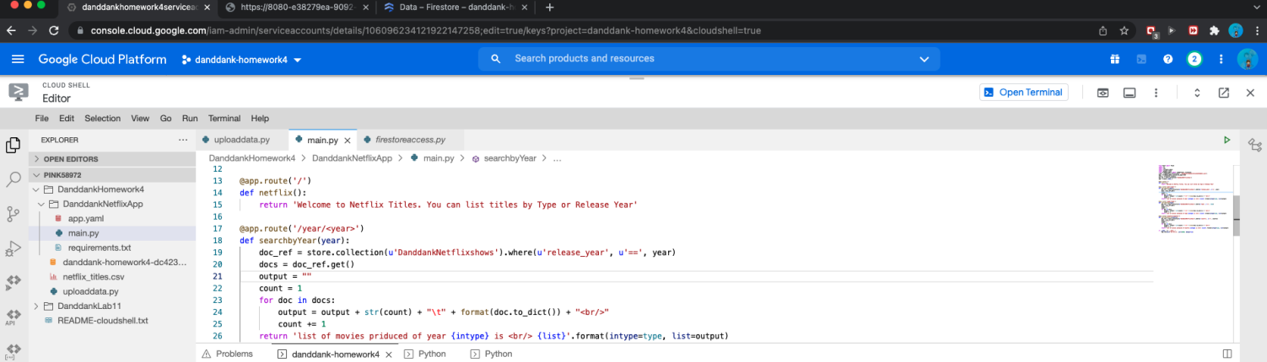

Homework screenshot #13:

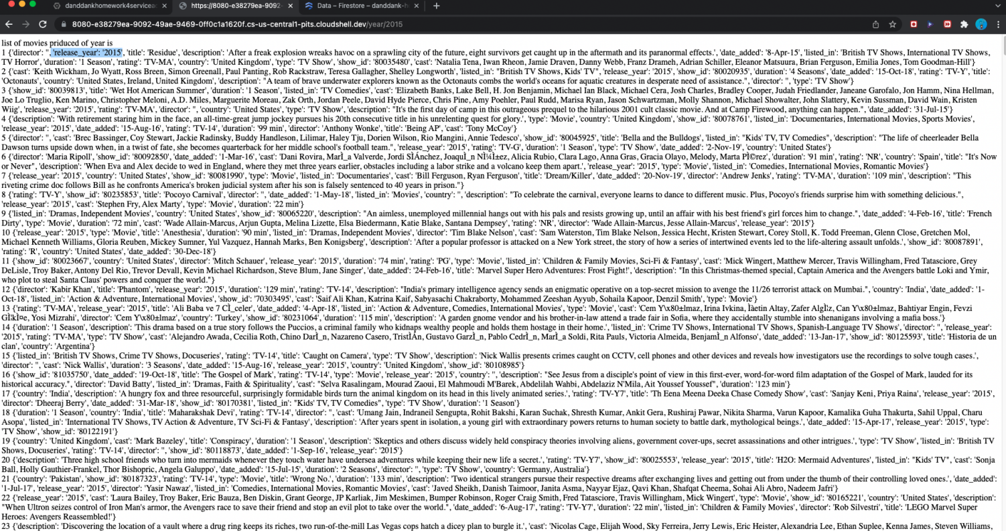

Homework screenshot #14:

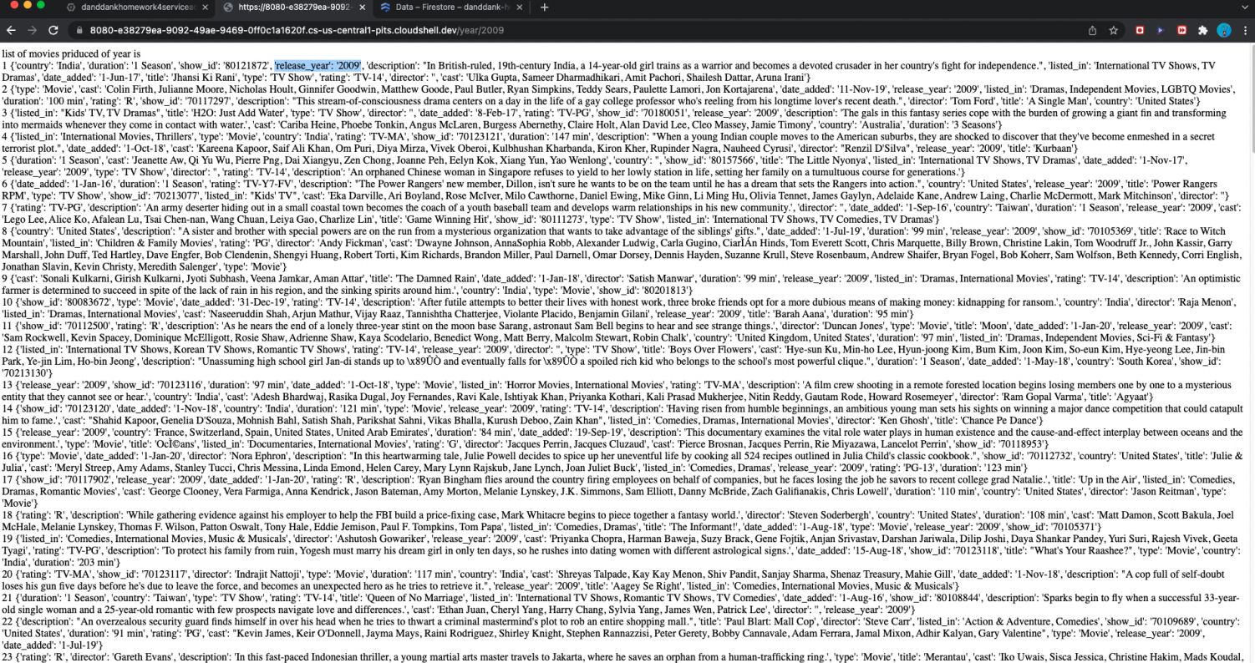

Homework screenshot #15:

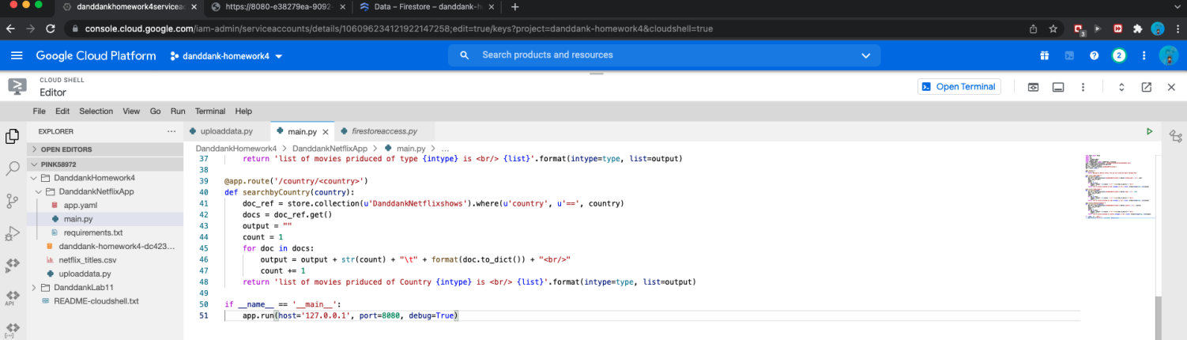

Homework screenshot #16:

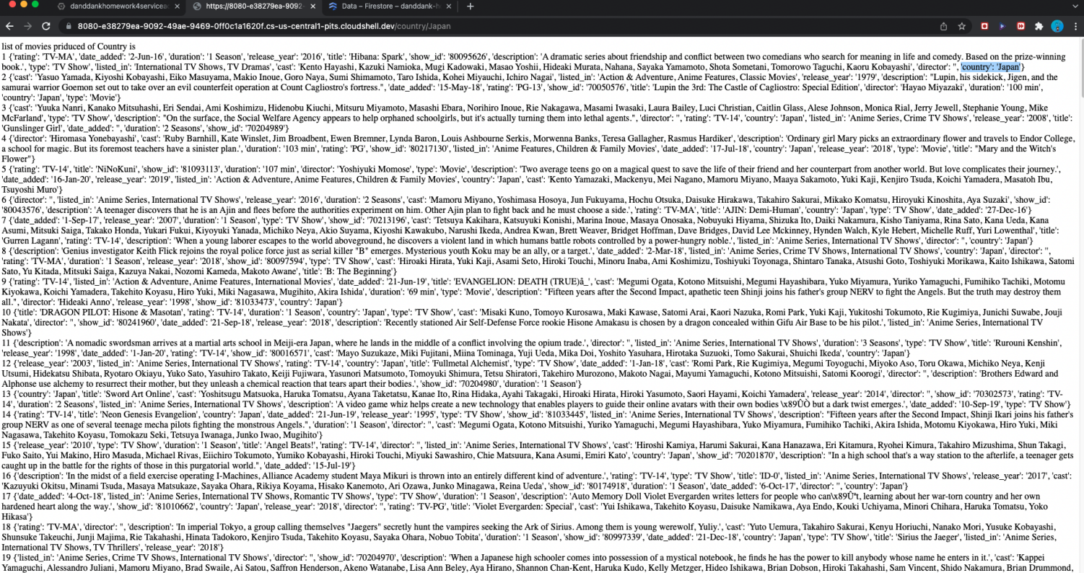

Homework screenshot #17:

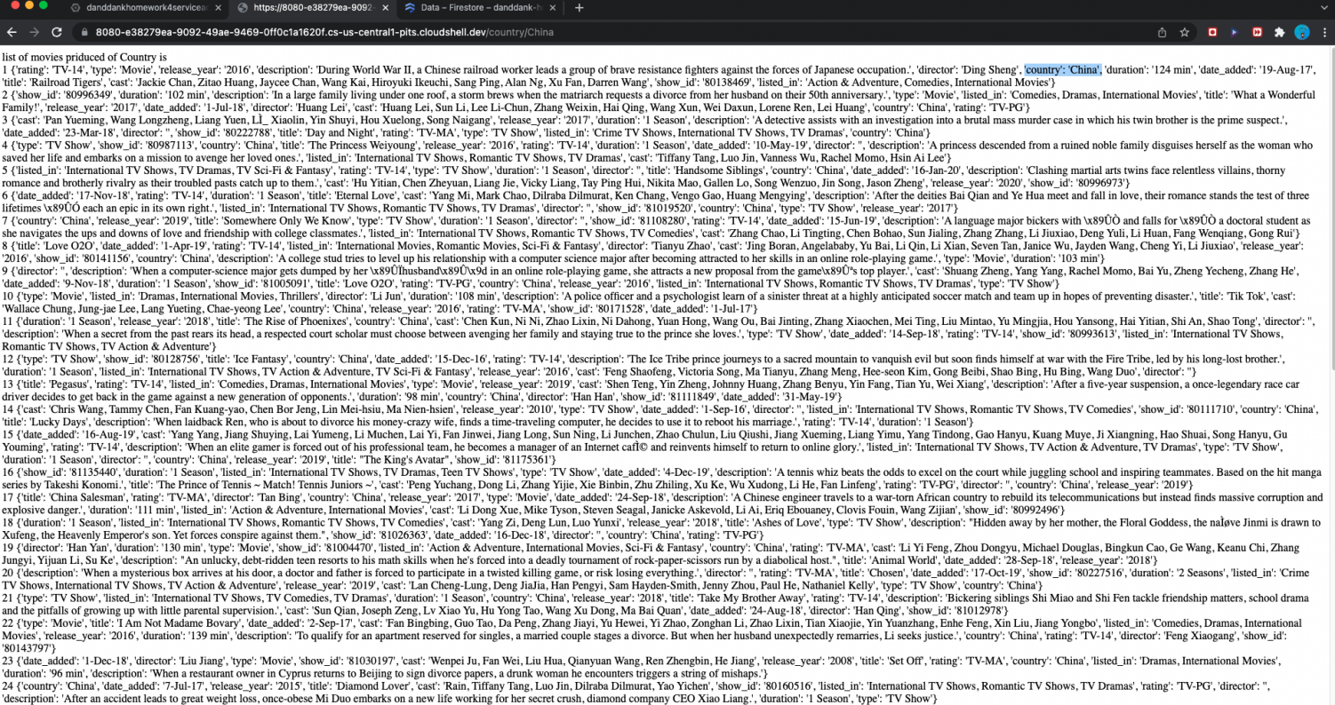

Homework screenshot #18:



Homework screenshot #19:

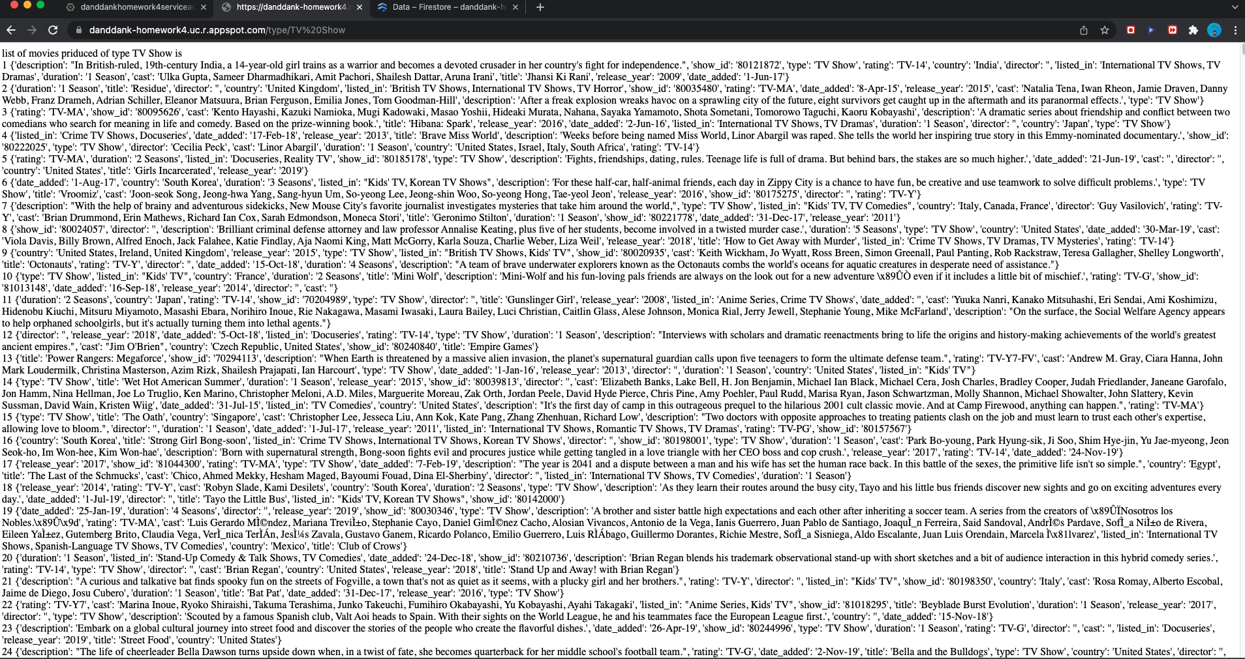

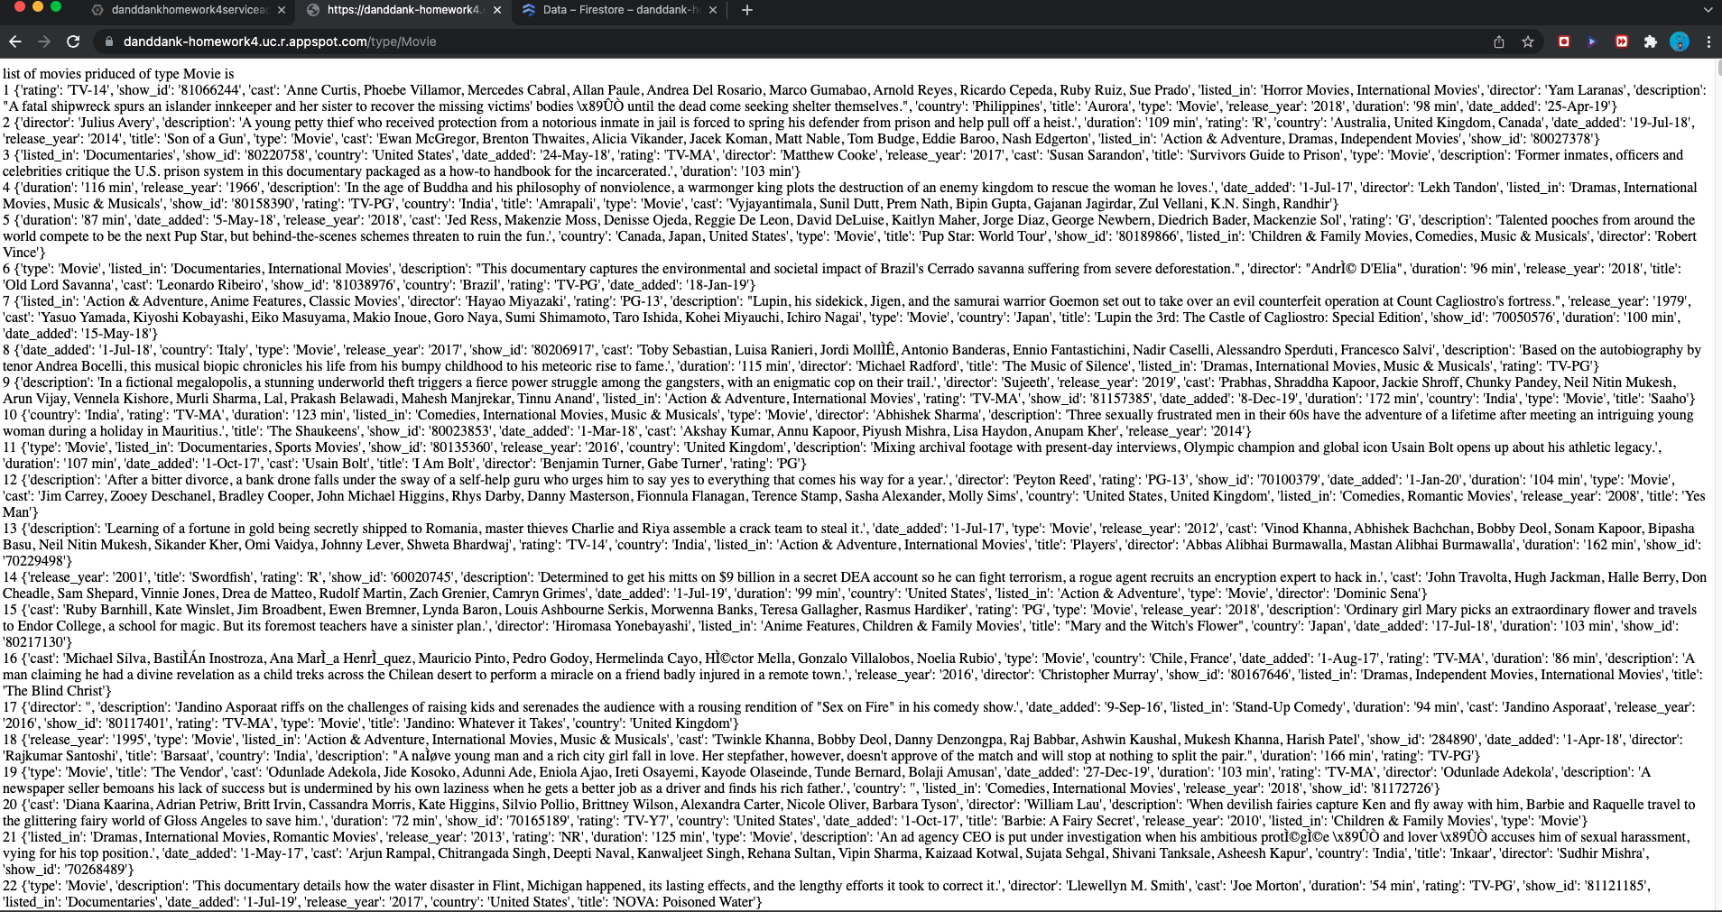

Homework screenshot #20:

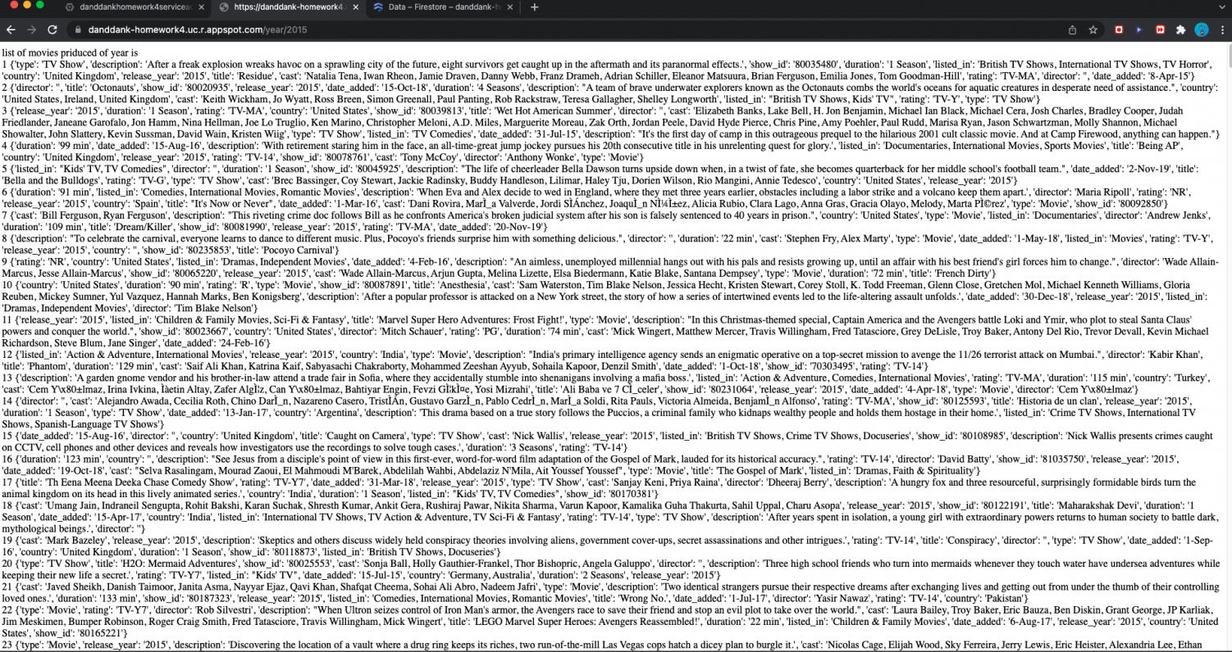

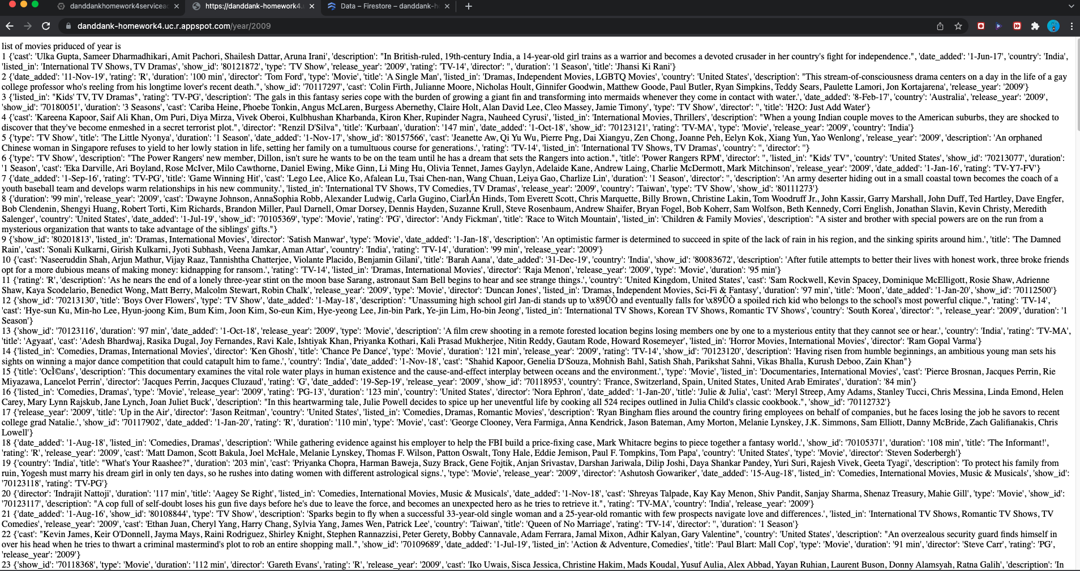

Homework screenshot #21:

